LIST OF PENDING PLACEMENTS
This user manual is for the placement tutor/team to view a list of placement applications that have not been reviewed and use a button for each of the functions to “APPROVE”, “FLAG” and “REJECT”.
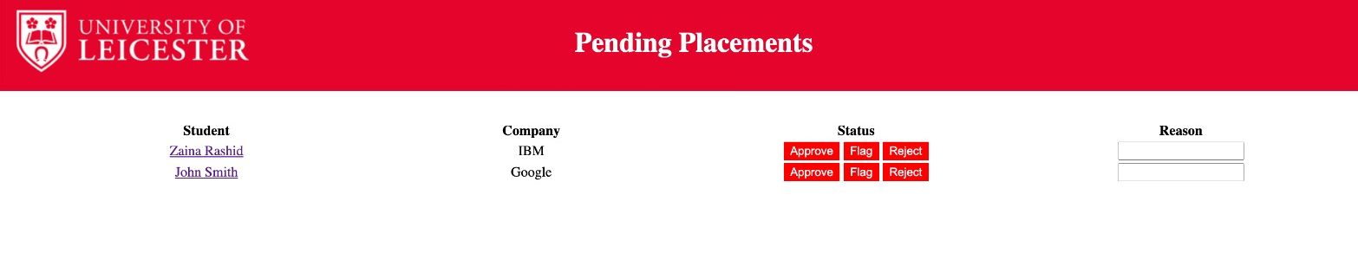
In the figure shown above, this table will list all the applications that are pending. For each of the placement application listed, the name of the students, the name of the organisation that they have applied to, and 3 buttons are displayed. The button “Approve” allows the application to be approved. The “Reject” button allows the application to be rejected. The button “Flag” allows the placement tutor to flag that application in order to be reviewed further.
When a placement tutor “flags” or “rejects” a student’s application, this selected application will have a red border around it. Alongside this, the tutor must provide a reason in the “Reason” box before they are able to “Flag” or “Reject” the application in order to ensure that these actions cannot occur without a reason being given.
When clicking on the student’s name directs to another page. This is an extra feature that is not part of this user story however it allows the placement tutor to view the details of the student.

By Bill, Abdulqader and Nina

Figure 66

